The Feeling of Reading in a Changing World:
From Neurons to Narratives
Tami Katzir
Edmond J. Safra Center for Brain and Learning Disabilities
University of Haifa

What is the nature of childhood today? According to a new OECD report, on many levels great improvement is evident in important measures: safety, health, and support for mental health and well-being. At the same time, children in the 21st century are reporting increased levels of anxiety and depression, among other things as a result of heightened pressure to excel in educational environments. New technologies allow children to stay connected, but at the same time, the sense of loneliness among human beings is growing (Burns & Gottschalk, 2019). Children today are reported to spend less time in old fashioned activities such as running around and socializing, and more time on computer screens (Burns & Gottschalk, 2019). Childhood is a critical neurological developmental period. It is a period in which important foundational cognitive and affective skills and neuronal connections are formed (Barret, 2017). Stable and positive relationships with parents, teachers, and peers are crucial for improving children’s wellbeing and social and emotional thriving (Choi, 2018). Supportive parents and teachers can provide children with skills and knowledge on how to deal with adversities in life (Pianta, 2009; Hamre & Pianta, 2001; Goldman et al., 2016).
In this paper, I will argue that meaningful reading programs in school can stimulate not only academic achievement but also a sense of community, purpose, and meaningful tools for dealing with the challenges of growing up in the 21st century. In fact, well designed evidence-based reading instruction can prepare children in the three important subcategories of defined 21st century skills: Literacy, Learning, and Life skills.
Reading books is a door to the world of imagination, to other realms, to endless possibilities of identifying with literary characters, working through challenges in one's personal life, and developing dreams of a wonderful future (Rot, 2019). Educators have the ability to grant students the gift of reading: not reading as a homework assignment but rather reading that has a magical effect and that generates strong feelings, sometimes even stronger than those facilitated in everyday life. Developing in young people the identity of a reading self, a person who takes time to learn about the environment, the world, and one’s self, will equip them with a strong foundation for building a caring society (Katzir & Lipka, 2017).
In this chapter, I will first address what reading looks like in a changing world. I will then review the literature linking cognition and emotion in reading in a mind, brain, and education framework. I will claim that an important component linking cognition and emotion in reading is listening. Listening can be widely defined and can propel cognitive and affective understanding of texts and human beings. I will then describe a national reading program we developed in Israel, called “Island of Understanding”, and the impact it has not only on reading but also on the feelings of children, teachers, and the community.
The global state of reading among children and adolescents
The topic of reading comprehension has become a focus of particular attention in the OECD and in other international organizations. International surveys support a strong link between cognition and emotion in reading habits and performance.
Children and young people who enjoy reading and who read daily are five times more likely to read above the level expected for their age compared to their peers who don’t enjoy reading. Overall, according to the National Literacy Trust (2019), children and young people’s reading engagement, their enjoyment of reading and reading frequency, especially of novels, have declined steadily over the past five years. The challenges we face as educators and researchers is to understand the circuits that support reading in the brain, and then translate them into meaningful engaging instruction in schools and communities.

The feeling of reading in the brain: insights from Mind, Brain, and Education
Recent converging research from behavior and brain science points to the importance of linking cognition and emotion in educational theory and practice. To quote Douglas Newton: “In today’s world, there is often so much emphasis placed on the intellect that the interaction between feeling and thinking is rarely identified. Nonetheless, emotions have a powerful effect on how we perceive the world and learn new knowledge” (2014).
In the field of reading, there are two rich yet often disconnected bodies of research and practice on the linguistic and affective components linked to comprehension (Katzir & Lipka, 2017).
New multi-componential models suggest that beyond language, memory, and visual systems, a wide set of emotions also play a role in the critical reading performance of children (Primor & Katzir, 2016; Katzir, Kim & Dotan, 2018; Meer & Katzir, 2016; Katzir, Lipka, Prior & Shany, 2019). Each reader comes to the text with different experiences, social-emotional skills, and a certain attitude towards a particular story and text (Conlon, Zimmer-Gembeck, Creed, & Tucker, 2006; Katzir, Markovich, Tesler, & Shany, 2018). Readers might be interested in the topic of the text or bored by it, motivated to read and learn new information or merely to pass a test, anxious that the task requires reading out loud or dealing with a painful subject from the past (Cartwright, Marshall, & Wray, 2016; Guthrie & Kaluda, 2014). Readers may even have a mental model of themselves as readers, one that affects their interaction with the text.
Recent research suggests that both positive and negative feelings are related to different levels of reading in children of all ages (Kasparski & Katzir, 2013, Kasperski, Shany & Katzir, 2016). Interestingly, rate of performance rather than accuracy is linked to reading self-concept and reading anxiety. In addition, young girls display higher levels of reading anxiety and lower confidence than boys (Katzir et al., 2018). A study examining galvanic skin response patterns during reading reported more arousal in poor vs. strong readers (Meer & Katzir, 2016). In addition, poor readers across all grades exhibit low reading self-concept (Kleider-Tesler, Prior & Katzir, 2019). In figure 1 we suggest a model linking cognition and emotion at the level of the reader, the text and the task.
New findings from brain imaging studies support the critical role of emotions in reading. The amygdala and temporal pole are considered important for social scripts, emotions, and judgments (Northoff & Bermpohl, 2004). Children’s processing of stories eliciting affective and cognitive empathy is associated with more medial and bilateral orbitofrontal cortex (OFC) activation (Brink et al., 2011).
Reading is both a personal and communal act. Reading is influenced by interactions at the home, in school, and in wider cultural settings. Studies indicate that home literacy is correlated with word reading and reading comprehension of children (Katzir, Lesaux & Kim, 2009). Children who come from homes with many books are significantly better readers than children with less books at home. In a recent study, poor readers as compared to good readers reported being more controlling and negative about shared reading time (Segal et al., in prep). Children born to mothers addicted to drugs, show delays in reading and math ten years after birth (Lee, Woodward & Henderson, 2019). Moreover, children from a low socio-economic background have significantly lower achievements on general vocabulary, reading comprehension, and knowledge of emotion words compared to children raised in wealthier environments (Sabag & Katzir, in prep).
The importance of high-quality relationships at home and of meaningful interactions around books is receiving initial support in neuroscience research. Innovative brain imaging studies indicate that when reading is shared, especially with a mother, the pattern of activation is different than when children view videos of the same stories (Hutton et al., 2017). Greater frontal lobe activation was found in children when they were engaged in a picture book reading task with their mothers, as opposed to passive viewing of a videotape in which the story was read to them.
Emotions are important not just within the reader and within the family but also between the child and her teacher (Cheung & Pomerantz, 2011; Segal, Shany & Katzir, in prep). In our lab we found that the quality of the relationship between a teacher and a struggling child she tutors predicts how much the child will improve in reading over the course of a year (Gallili et al., in prep). This is a self-fulfilling prophecy that the teacher sets for the child.
Despite the growing evidence from affective neuroscience and behavior research, most reading programs tend to focus on technical skills associated with reading (National Reading Panel, 2000), with less of an emphasis on enhancing interest, excitement, and dealing with anxiety and boredom that may arise in students.
Linking Cognition and Emotion in Reading Through Value
One way to entice children to engage in reading is to let them read about topics they encounter every day in their development, moral dilemmas and core values they form in these critical years. Teaching through exposure to dilemmas lets children concurrently develop the three important skills of literacy, learning, and life.
Morais (2018) argues that the more literate individuals are - the better they participate in exercising control over the affairs of their community and can contribute to true democratic governing. This idea is particularly challenging in light of the fact that, as Morais reminds us, illiteracy rates remain quite high worldwide.
The traditional approach is that values are taught in the homeroom or in social studies rather than in language lessons, but in the multidimensional approach learning from role models and reading about dilemmas is considered the most comprehensive way of learning about values while observing and listening to others and to oneself (Narvaez et al., 1998). This is especially relevant in light of the digital revolution.
The Value of Listening in an Era of Digital Literacy.
Contemporary literacy encompasses interactions with the written word on screens, oral language, and processing images via videos, podcasts, and other digital communication formats (Wolf, 2018).
Digital media have in fact revived the importance of listening and of oral literacy (Meyer, Rose, & Gordon, 2014). In the 21st century, listening can play an essential role in supporting learners with diverse needs, abilities, and styles. Tools such as digital text, text-to-speech, and audio books offer powerful alternatives to traditional classroom materials that rely almost exclusively on printed text.
However, at present listening does not always involve an active interlocutor. That is, one can listen to a digital device at the press of a button. As such, listening does not necessarily entail nor promote dialogue nor empathy. As this is the new reality, we need to make a point of emphasizing the development of active emphatic listening to others, to the environment, to one’s self, rather than only the technical taking in of surface facts involved in person-computer interactions. Shared reading, as stemming in origin from religious contexts and in the educational context, can serve to advance these skills.
In order for children in the 21st century to not only listen to technology but truly engage in transformational listening, let us revisit the ideas of German Philosopher Martin Buber. Martin Buber’s famous text, I and Thou (Ich und Du, 1923) presents a philosophy of personal dialogue, in that it describes how personal dialogue can define the nature of reality. Buber’s major theme is that human existence may be defined by how we engage in dialogue with each other, with the world, and with God.
According to Buber, human beings may adopt two attitudes toward the world: I-Thou or I-It. In the I-Thou relationship, human beings are aware of each other as having a unity of being. In the I-Thou relationship, human beings engage in a dialogue involving each other's whole being. In the I-It relationship, which is becoming much more prevalent in children’s reality where the IT can represent a screen of a YouTube video, human beings perceive each other as consisting of specific, isolated qualities, and view themselves as part of a world that consists of things. The relationship that education systems should focus on enhancing in children, and for which reading can serve as a vehicle, is the I-Thou relationship of emphatic listening and reciprocity.
According to the international Listening Association, listening is a critical language skill necessary for competent communication in its many manifestations (e.g., reading, speaking). Listening can also be defined as an ethical endeavor, a pure non-egocentric form, a way of knowing and valuing the other person.
Finally, listening can be defined as part of an experiential and social interaction, as a communal activity. This perspective incorporates theories and principles from storytelling, narrative theory, therapeutic listening, experience, and phenomenology.
These aspects of listening are typically not part of the language arts and reading curriculum. When reading, a child can be taught to listen to herself, listen to the environment, and listen afterwards to the community that reads a similar or different text. Active emphatic listening will allow the child to come out of the reading experience changed and enriched.
The need to develop emphatic listening through reading, builds on the understanding that cognition and emotion are strongly linked in every human action on the brain and behavior levels.
In a large national-based study, we developed a universal reading program that builds on cutting edge research in cognitive and affective neuroscience and behavior. We also consulted with value researchers, literature scholars, teachers, and students. Our goal was to create an encompassing experience for elementary school children, one in which reading will take them on an adventure that will teach them about themselves, their environment, and how to listen to each other.
Findings from the "Island of Understanding"
We constructed a background story of students who find themselves on an island where they must survive on their own. On the island, the students encounter social dilemmas that involve both physical and emotional predicaments. The dilemmas were chosen to map Schwartz’s value (1992). In order to learn life lessons about friendship, survival, listening, and self-identity, the students read journals and letters, as well as historical and current texts. In the program, the students are also exposed to role models from whom they can learn about coping with stressful situations, overcoming difficulties, and acquiring values that can be applied to their personal life.
Hence, in this program reading is performed for the purpose of survival – physical, emotional, and social. After reading, students are required to carry out different assignments aimed at developing a rich vocabulary, reading flow, and skills of oral and written expression. The approach underlying the program is that reading is an essential source of learning both about the world and about one's self.
In addition, the program focuses on the topic of active listening. The children learn that we often "hear" others but do not necessarily listen to them attentively. In the program, after the topic of listening has been grasped, students learn about active listening to the text. They learn that reading requires active listening to the text without jumping to conclusions, while attending to the perspectives of the author or of various characters in the story and developing the ability to formulate the text's words reflectively after listening. The message for students is that the purpose of reading is not to answer questions on a test, but rather to understand the author, his or her aim, the information conveyed, what meaning this information has for them as readers, what emotions the text arouses in them, what thoughts, to what prior knowledge the content is related. The assumption is that promoting listening on all levels will facilitate verbal and nonverbal communication among the students and will even change their patterns of active reading. The program teaches, both directly and indirectly, foundational literacy skills such as strategies for reading comprehension before, during, and after reading a text.
Over the past two years we ran the program with nearly 2500 students and 120 teachers (Katzir, Lipka, Prior, & Shany, 2019). In a randomized controlled study, we found that The children who participated in the program reported more excitement, interest, and confidence in reading after their experience “on the island” compared to a control group. They also significantly outperformed children who did not participate, on all reading measures. Teachers who took part in this program shared that their relationship with the children improved and that a sense of community was created through this experience.
Summary: The feeling of connected value-based reading
In conclusion, the key to promoting literacy in 21st century children should be through meaningful shared learning experiences. Literacy impacts not only individual minds but also society and humanity as a whole. In order to retain reading as a central human experience the links between cognition, emotion, and value should be embedded in reading instruction and curriculum. Further, an important skill to add to the 21-century list is empathic listening. The skills addressed in the program tie together cognition and emotion and allow for literacy learning as well as building life skills. The “Island of Understanding” program demonstrates that reading is first and foremost an emotional process. Reading builds on a foundation consisting of rich vocabulary, reading flow, and cognitive and metacognitive abilities. Improving students' reading comprehension, however, must begin by encouraging them to willingly and enthusiastically engage in considerable and thorough reading and also open their minds and hearts to listening. In order to expand and improve not only the state of literacy, as well as to develop a strong community of contentious young people who experience reading with feeling, there is need to shift to a model of reading programs that incorporate values, relationships, as well as evidence based pedagogical practices informed by multiple disciplines ranging from linguistics and literature to cognitive and affective neurosciences. In order to truly promote literacy not merely for purposes of international or local exams, we must place reading at the center of the learning process. Lessons from imaging, behavioral and educational research indicate the a shift from “”cogno-centric” teaching to integrated reading instruction impact society by helping close important educational gaps.

References
Barrett, L. F. (2017). How emotions are made: The secret life of the brain. Houghton Mifflin Harcourt.‏
Bierman, K. L., Domitrovich, C. E., Nix, R. L., Gest, S. D., Welsh, J. A., Greenberg, M. T. & Gill, S. (2008). Promoting academic and social‐emotional school readiness: The Head Start REDI program. Child Development, 79(6), 1802-1817.‏
Brink, T. T., Urton, K., Held, D., Kirilina, E., Hofmann, M., Klann-Delius, G., ... & Kuchinke, L. (2011). The role of orbitofrontal cortex in processing empathy stories in 4-to 8-year-old children. Frontiers in Psychology, 2, 80.‏
Buber, M. (1923). Ich und du [Me and you]. Stuttgart: Reclam.
Burns, T. and F. Gottschalk (eds.) (2019). Educating 21st Century Children: Emotional Well-being in the Digital Age: Educational Research and Innovation. OECD Publishing, Paris.
Cain, K., Oakhill, J., & Lemmon, K. (2004). Individual differences in the inference of word meanings from context: The influence of reading comprehension, vocabulary knowledge, and memory capacity. Journal of Educational Psychology, 96(4), 671.‏
Cartwright, K. B., Marshall, T. R., & Wray, E. (2016). A longitudinal study of the role of reading motivation in primary students’ reading comprehension: Implications for a less simple view of reading. Reading Psychology, 37(1), 55-91.‏
Cheung, C. S. S., & Pomerantz, E. M. (2011). Parents’ involvement in children’s learning in the United States and China: Implications for children’s academic and emotional adjustment. Child development, 82(3), 932-950.‏
Choi, A. (2018). “Emotional well-being of children and adolescents: Recent trends and relevant factors”, OECD Education Working Papers, No. 169, OECD Publishing, Paris, https://dx.doi.org/10.1787/41576fb2-en.
Conlon, E. G., Zimmer-Gembeck, M. J., Creed, P. A., & Tucker, M. (2006). Family history, self-perceptions, attitudes and cognitive abilities are associated with early adolescent reading skills. Journal of Research in Reading, 29(1), 11-32.
Christina, C. (2019). Children and young people’s reading in 2017/18. National Literacy Trust. Retrieved from https://literacytrust.org.uk/research-services/research-reports/children-and-young-peoples-reading-201718/García, J. R., & Cain, K. (2013). Decoding and reading comprehension: A meta-analysis to identify which reader and assessment characteristics influence the strength of the relationship in English. Review of Educational Research, 0034654313499616.‏
Goldman, E., Stamler, J., Kleinman, K., Kerner, S., & Lewis, O. (2016). Child mental health: Recent developments with respect to risk, resilience, and interventions. In Health Promotion for Children and Adolescents (pp. 99-123). Springer, Boston, MA.‏
Gough, P., & Tunmer, W. (1986). Decoding, reading, and reading disability. Remedial and Special Education, 7, 6–10. doi:10.1177/074193258600700104
Graesser, A. C., Singer, M., & Trabasso, T. (1994). Constructing inferences during narrative text comprehension. Psychological Review, 101(3), 371.‏
Guthrie, J. T., & Klauda, S. L. (2014). Effects of classroom practices on reading comprehension, engagement, and motivations for adolescents. Reading research quarterly, 49(4), 387-416.‏
Hamre, B. K., & Pianta, R. C. (2001). Early teacher–child relationships and the trajectory of children's school outcomes through eighth grade. Child development, 72(2), 625-638.‏
Hutton, J. S., Phelan, K., Horowitz-Kraus, T., Dudley, J., Altaye, M., DeWitt, T., & Holland, S. K. (2017). Shared reading quality and brain activation during story listening in preschool-age children. The Journal of pediatrics, 191, 204-211.‏
Hutton, J. S., Phelan, K., Horowitz-Kraus, T., Dudley, J., Altaye, M., DeWitt, T., & Holland, S. K. (2017). Story time turbocharger? Child engagement during shared reading and cerebellar activation and connectivity in preschool-age children listening to stories. PloS one, 12(5).‏
Imhof, M. (2001). How to listen more efficiently: Self-monitoring strategies in listening. International Journal of Listening, 15, 2-19. Imhof, M. (in press). The cognitive psychology of listening. In A. D. Wolvin (Ed.), Listening and human communication in the 21st century. Boston: Blackwell.
Kasperski, R., & Katzir, T. (2013). Are confidence ratings test-or trait-driven? Individual differences among high, average, and low comprehenders in fourth grade. Reading Psychology, 34(1), 59-84.‏
Kasperski, R., Shany, M., & Katzir, T. (2016). The role of RAN and reading rate in predicting reading self-concept. Reading and Writing, 29(1), 117-136.‏
Katzir, T., Kim, Y.S., & Dotan, S. (2018). Reading self-concept and reading anxiety in second grade children: The roles of word reading, emergent literacy skills, working memory and gender. Frontiers in Psychology, 9, 1180
Katzir, T., Lesaux, N. K., & Kim, Y. S. (2009). The role of reading self-concept and home literacy practices in fourth grade reading comprehension. Reading and Writing, 22(3), 261-276.
Katzir, T., Lipka, O., Prior, A & Shany, M. (2019). From mapping to intervention a multi componential model for Teacher Training. Report submitted to the Chief of Science, Israeli Ministry of Education. 200 pp.
Katzir, T., & Lipka. O. (2017). An island of understanding - Teacher's manual. University of Haifa, Israel.
Katzir, T., Markovich, V., Tesler, E., & Shany. M. (2018). Self-Regulation and Reading Comprehension: Self-Perceptions, Self-Evaluations, and Effective Strategies for Intervention. In Executive Function in Education: From Theory to Practice (pp. 240-262) (Ed. Meltzer L). Guilford Publications.
Keenan, J. M., Betjemann, R. S., & Olson, R. K. (2008). Reading comprehension tests vary in the skills they assess: Differential dependence on decoding and oral comprehension. Scientific Studies of Reading, 12(3), 281-300.‏
Kleider-Tesler, E., Prior, A., & Katzir, T. (2019). The Role of Calibration of Comprehension in Adolescence: From Theory to Online Training. Journal of Cognitive Education and Psychology, 18(2), 190-211.‏
Lee, S. J., Woodward, L. J., & Henderson, J. M. (2019). Educational achievement at age 9.5 years of children born to mothers maintained on methadone during pregnancy. PloS one, 14(10).
Meer, Y., Breznitz, Z., & Katzir, T. (2016). Calibration of self‐reports of anxiety and physiological measures of anxiety while reading in adults with and without reading disability. Dyslexia, 22(3), 267-284
Meyer, A., Rose, D.H., & Gordon, D. (2014) Universal design for learning: Theory and practice, Wakefield MA: CAST.
Morais, J. (2018). Literacy and democracy. Language, Cognition and Neuroscience, 33(3), 351–372.
Narvaez, D., Bentley, J., Gleason, T., & Samuels, J. (1998). Moral theme comprehension in third graders, fifth graders, and college students. Reading Psychology: An International Quarterly, 19(2), 217-241.
National Reading Panel (US), National Institute of Child Health, Human Development (US), National Reading Excellence Initiative, National Institute for Literacy (US), United States. Public Health Service, & United States Department of Health. (2000). Report of the National Reading Panel: Teaching children to read: An evidence-based assessment of the scientific research literature on reading and its implications for reading instruction: Reports of the subgroups. National Institute of Child Health and Human Development, National Institutes of Health.‏
Newton, D. P. (2014). Thinking with Feeling: Fostering productive thought in the classroom. Routledge.‏
Northoff, G., & Bermpohl, F. (2004). Cortical midline structures and the self. Trends in cognitive sciences, 8(3), 102-107.‏
Orrantia, J., Mu´n˜ez, D., & Tarı´n, J. (2014). Connecting goals and actions during reading: The role of illustrations. Reading and Writing, 27(1), 153–170.
Pianta, R. C. (2009). School psychology and developmental psychology: Moving from programs to processes. The handbook of school psychology (4th ed., pp. 107-123). New York, NY: Wiley.‏
Primor, L., & Katzir, T. (2016). Linking cognition and emotion: into reading comprehension instruction. In: Lipka, O., & Katzir, T (Editors). Linking emotion, cognition and reading comprehension: from theory to practice. University of Haifa, Israel.
Schwartz, S. H. (1992). Universals in the content and structure of values: Theory and empirical tests in 20 countries. In M. Zanna (Ed.), Advances in experimental social psychology (Vol. 25, pp. 1-65). New York: Academic Press. http://dx.doi.org/10.1016/S0065-2601(08)60281-6
Snow, C. (2002). Reading for understanding: Toward an R&D program in reading comprehension. Santa Monica, CA: Rand Corporation.
Sweet, A. P., & Snow, C. (2002). Reconceptualizing reading comprehension. Improving comprehension instruction, 17-53.‏
Wolf, M. (2018). Reader, come home: The reading brain in a digital world. New York, NY: Harper.
Zwaan, R. A., Langston, M. C., & Graesser, A. C. (1995). The construction of situation models in narrative comprehension: An event-indexing model. Psychological science, 292-297.‏

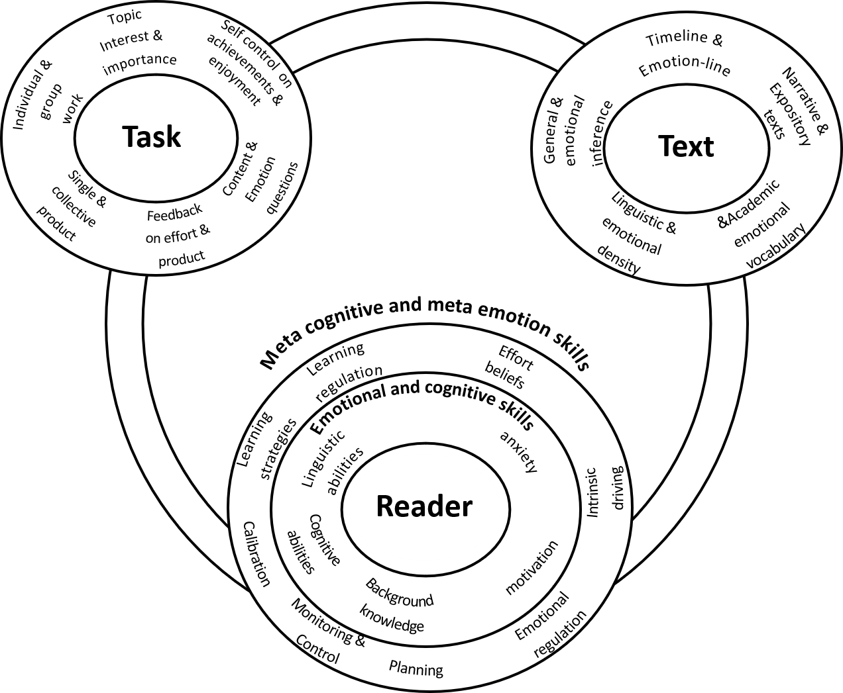
Figure 1-Linking cognition and emotion at the level of the reader, the task and the test

